Collins’s Death Timeline of Events
Source - InterOcean 1/20/1877
- Monday 1/15/1877 - Collins tried to resign, but it wasn't accepted. “I have worked for thirty years, with what fidelity God knows, for the protection and safety of the public, and now the public, forgetting all these years of service, has turned against me.” Charles Collins (Peet, 162)
- Wednesday afternoon 1/17/1877 - Collins testifies before the Legislative committee. By the way, the Ohio Legislative Committee met at the Kennard House in Cleveland.
- Wednesday late afternoon/early evening 1/17/1877 - Collins met a prominent bridge builder (no name given) and invited to form a party of engineers to tour the bridges from Cleveland to Toledo. He accepted the offer and then went to the office on Water Street to transact some business.
- Wednesday, around 9:00 pm 1/17/1877 – Collins met another person who was to go on the inspection tour. Collins told him that he changed his mind and wouldn’t be going on the trip. He asked him to inform the man he met earlier in the day. Collins heads home.
- Wednesday late evening 1/17/1877 – Collins is murdered or commits suicide.
- Thursday morning 1/18/1877 – Collins was missed at the office, but since he is often out no one thought much about it. Collins’s wife was in Ashtabula staying at the Harmon House.
- Friday morning 1/19/1877 – The city of Ashtabula buries the 50 unknown dead in Chestnut Grove Cemetery. Charles Collins is still missing. Mr. Charles Paine, General Superintendent of the line sends telegraphs to several points, including to Ashtabula, but nothing whatever was learned.
- Friday Afternoon 1/19/1877 - Isaac Brewer, Charles Collins assistant, went to his home in Cleveland, OH knocked and rang the doorbell. No one answered. The housekeeper was absent at the time.
- Saturday morning 1/20/1877 – at 10:15 Mr. Isaac Brewer, goes to the house again and the servant is in. He questions the servant who says he hasn’t seen Collins in a couple days nor has been to his bedroom. Brewer goes into the home to do a search and finds Collins dead.
  - Collins body was on the bed. Bullet hole in the head. Body was already decomposing. InterOcean article states that it was believed that Collins put the gun in his mouth and the bullet was found in the wall. However, this was disproven.
  - Brewer stated – Looking around the room he could see Charles Collins’ bag was packed and it looked like he was planning on going on the bridge inspection tour or since Collins cancelled that trip, he may have been heading to Ashtabula for the completion of the replacement bridge.
  - "There is little doubt but that Mr. Collins intended to go on the proposed tour of inspection on Thursday, for his traveling-bag was found neatly packed in the bed-room.” Rev. Stephen Peet, (The Ashtabula Disaster) p. 163 published in 1877.
  - Mr. Brewer immediately summoned someone in the streets to get word to the Railroad officials and to the Police.
  - Superintendent Paine, Captain Henry Holzworth of the Cleveland Detective force and a physician arrived about the same time. Coroner Filedner came later. By this time a crowd had formed, which had to be controlled by the police.
  - “The Coroner, after viewing the remains, decided that the fact of the suicide was so clear that he would hold no inquest.”

- Saturday Afternoon 1/20/1877 – Mrs. Collins received a telegram about her husband. She arrives at 3:00pm with her brother Mr. Albert Harmon and her sister. “Mrs. Collins is almost inconsolable in her grief.”
Notes: The replacement bridge was finished on Thursday 1/18/1877. I would think that Collins might have wanted to be there. Maybe that is why he cancelled the inspection tour. I am also surprised that Collins didn't make plans to go to the memorial service on Friday 1/19/1877. Although he might not want to go since he felt that people were blaming him.

Source: Cincinnati Commercial Newspaper, 11/16/1877
Friday November 16, 1877 – Report surfaces that Collins was murdered. Brewer, Honorable George L. Converse, Chairman of the Joint Committee that investigated the disaster, and Collins’s wife all believed from the beginning that Charles was murdered. Detectives are now working on the case, and possibly may throw some light on the question, Was Charles Collins murdered?

How the body was found: Source - Bliss and Tragedy: Dr. Frank H. Hamilton, 1878
“His left arm and hand were found lying parallel to his body, or nearly so – the hand partly over and across the thigh, with the weapon lying loosely in his hand- that the right arm was in a similar position in relation to the right side of his body – that the bed clothes were drawn up to a point above the waist; that his legs were extended, and that this whole body was in a condition of easy and natural repose.” Letter written by Dr. Frank H. Hamilton, 1878 (B&T, pg155)
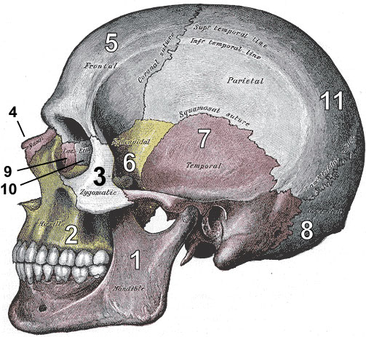
What happened: Source - Bliss and Tragedy: Dr. Frank H. Hamilton, 1878
Using a Colt Navy revolver (found in his left hand) a ball entered at the opening found in the skull back of the center of the left parietal bone, and emerged through the right parietal bone near the coronal suture. Collins was right handed. Dr. Frank H. Hamilton, 1878 (B&T, pg 155)

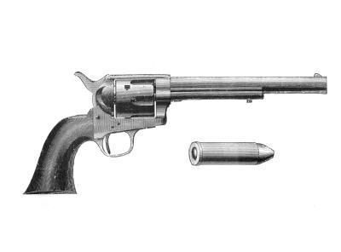

Findings: Source - Bliss and Tragedy: Dr. Frank H. Hamilton, 1878
- “It is highly improbable that a man who is right handed would use his left hand in shooting himself in the head” (B&T, pg 155)
- “It would, in fact, be exceedingly difficult for a man, not left handed, to hold such a weapon, with his left hand, in the position in which it must have been held for the ball to take the course which it did take…” (Hamilton (B&T, pg 156)
- “In short, if Mr. Collins was rendered immediately unconscious and was completely paralyzed, and remained so until death, (which was probably the fact) the position of the left arm, and hand, and of the revolver is not satisfactorily explained, upon the theory of suicide. The body laid too naturally for such a sudden shock to the system.
- A blow to the head was inflicted by a roller on which a towel was hung. The frame to which this roller was attached was found broken, and the roller itself was not discovered for month. (Cincinnati Commercial 11/16/87)

